**6.3 The Percent Proportion**

EQ: How can we use the percent proportion to find parts, wholes and percents?

Percent statements such as “25% **of** 12 is 3” have ***three*** numbers. In real-life problems, any one of these numbers can be unknown. We can use the **percent proportion** to solve for any of the three unknowns.

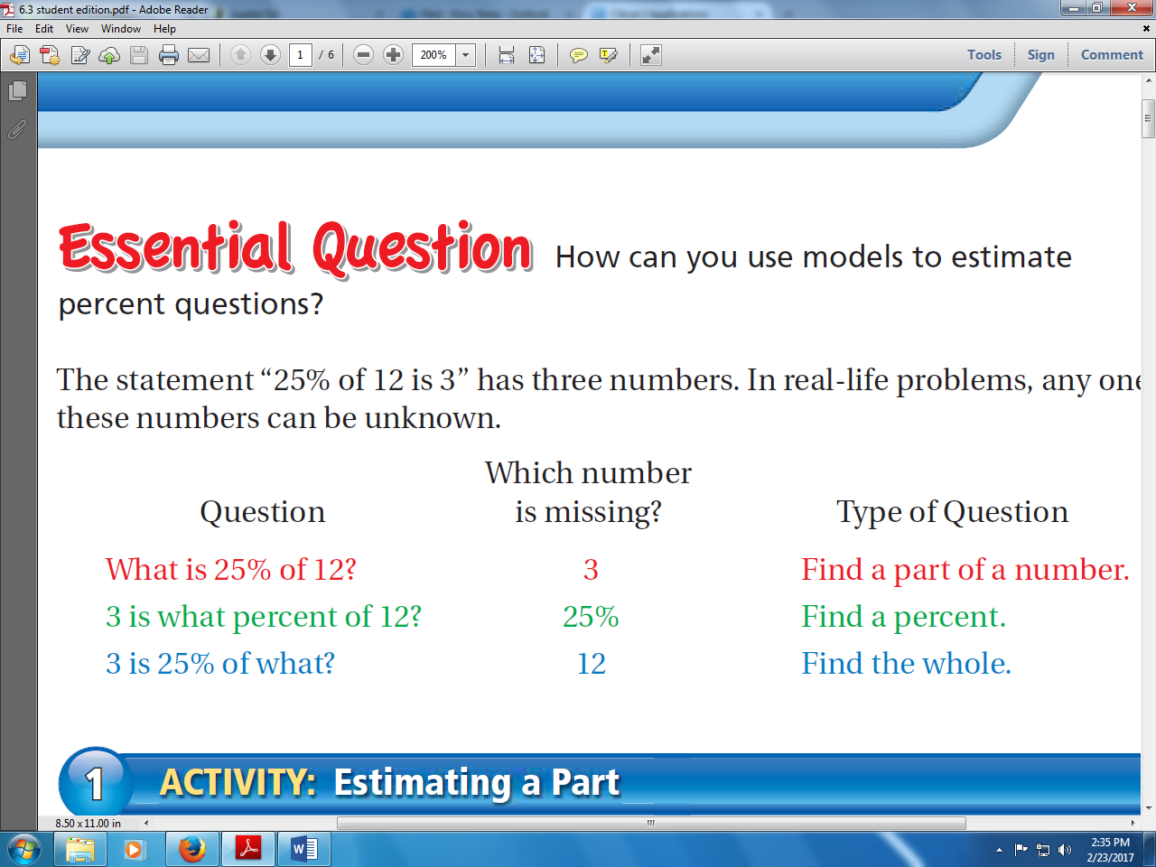

= **a**

= **p**

= **w**

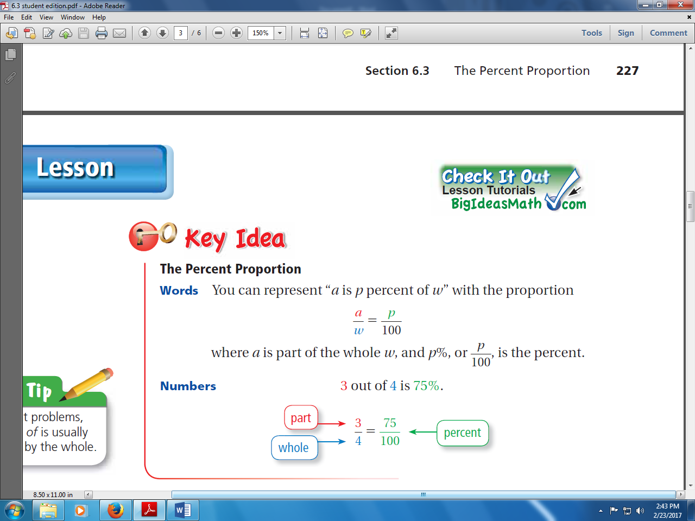

*In PERCENT problems, the word **OF** is usually followed by the **whole**\*

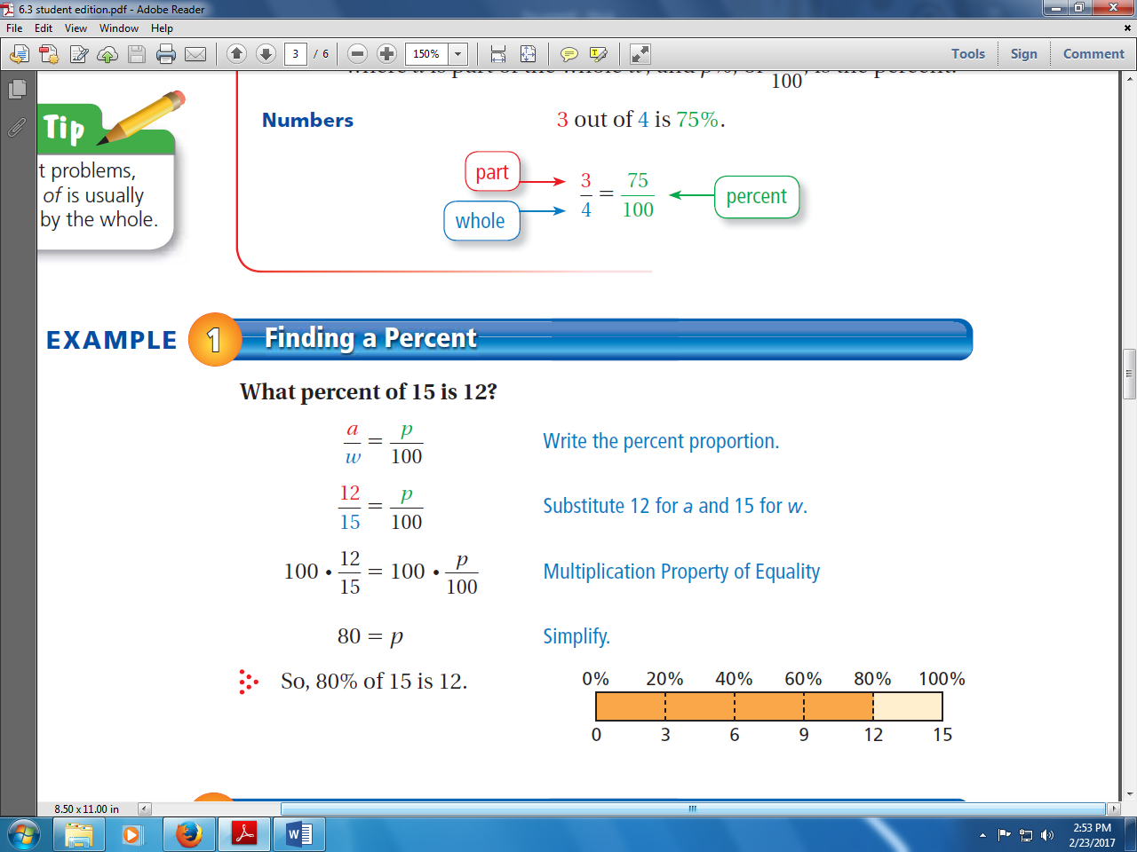

**What percent of 15 is 12?**

**Step 1: Write the percent proportion.**

**Step 2: Substitute 12 for a and 15 for w.**

**Step 3: Solve for p.**



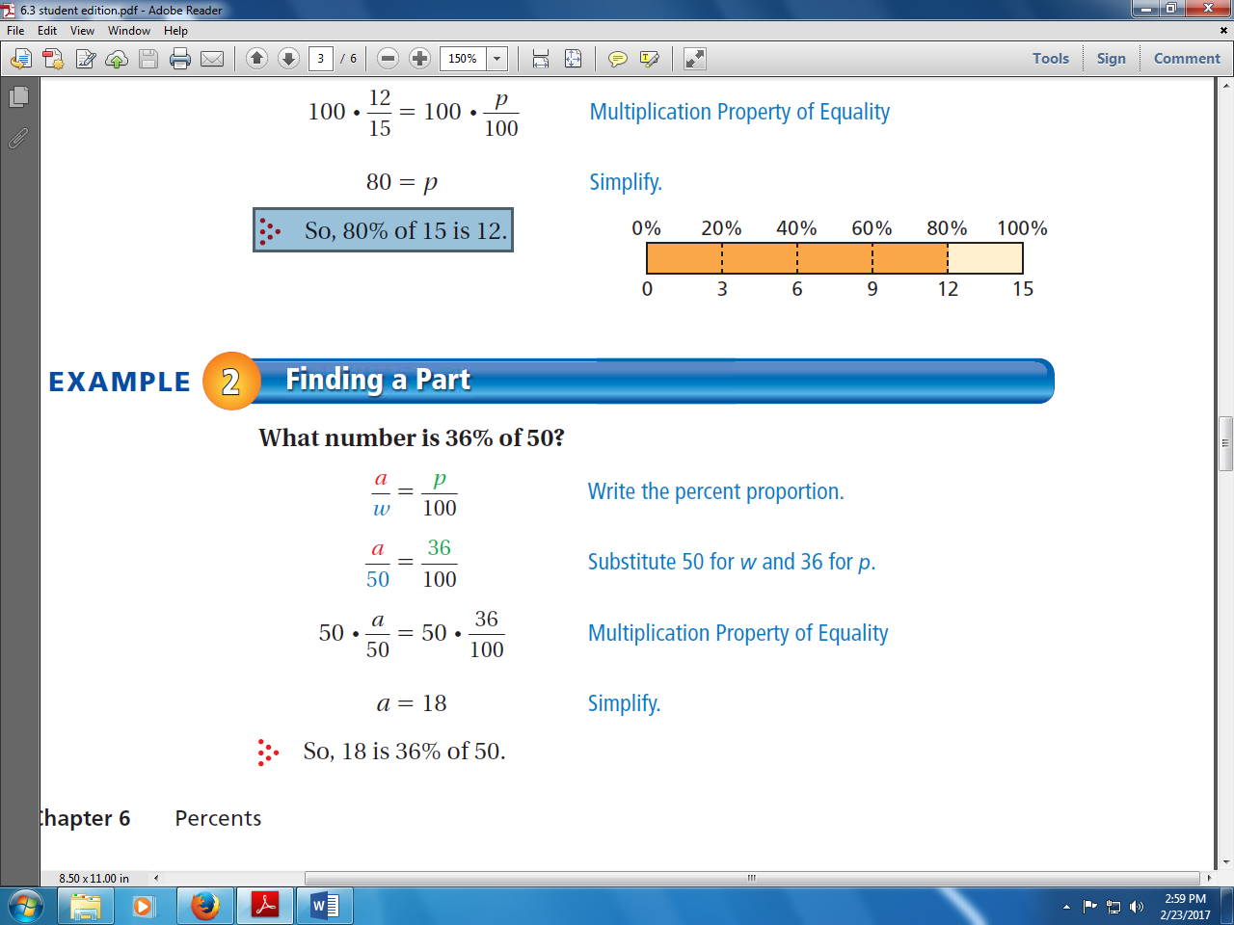**What number is 36% of 50?**

**Step 1: Write the percent proportion.**

**Step 2: Substitute 50 for w and 36 for p.**

**Step 3: Solve for a.**



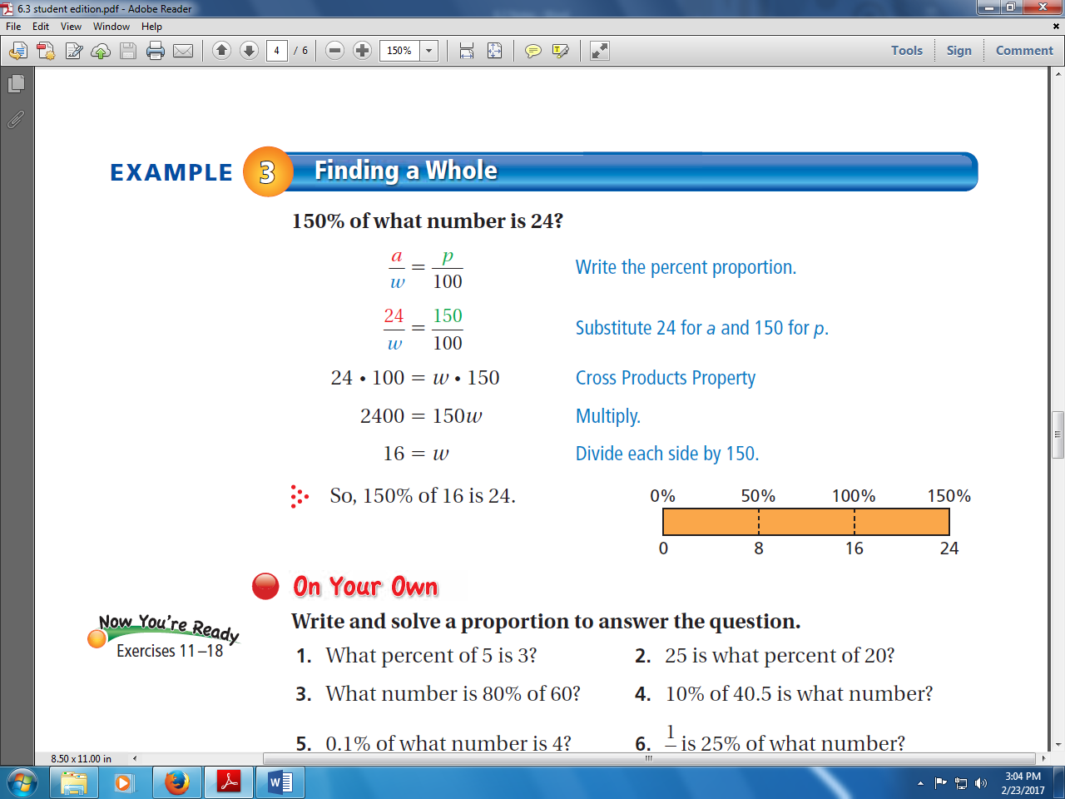

**150% of what number is 24?**

**Step 1: Write the percent proportion.**

**Step 2: Substitute 24 for a and 150 for p.**

**Step 3: Cross Multiply.**

**Step 4: Solve for w**.

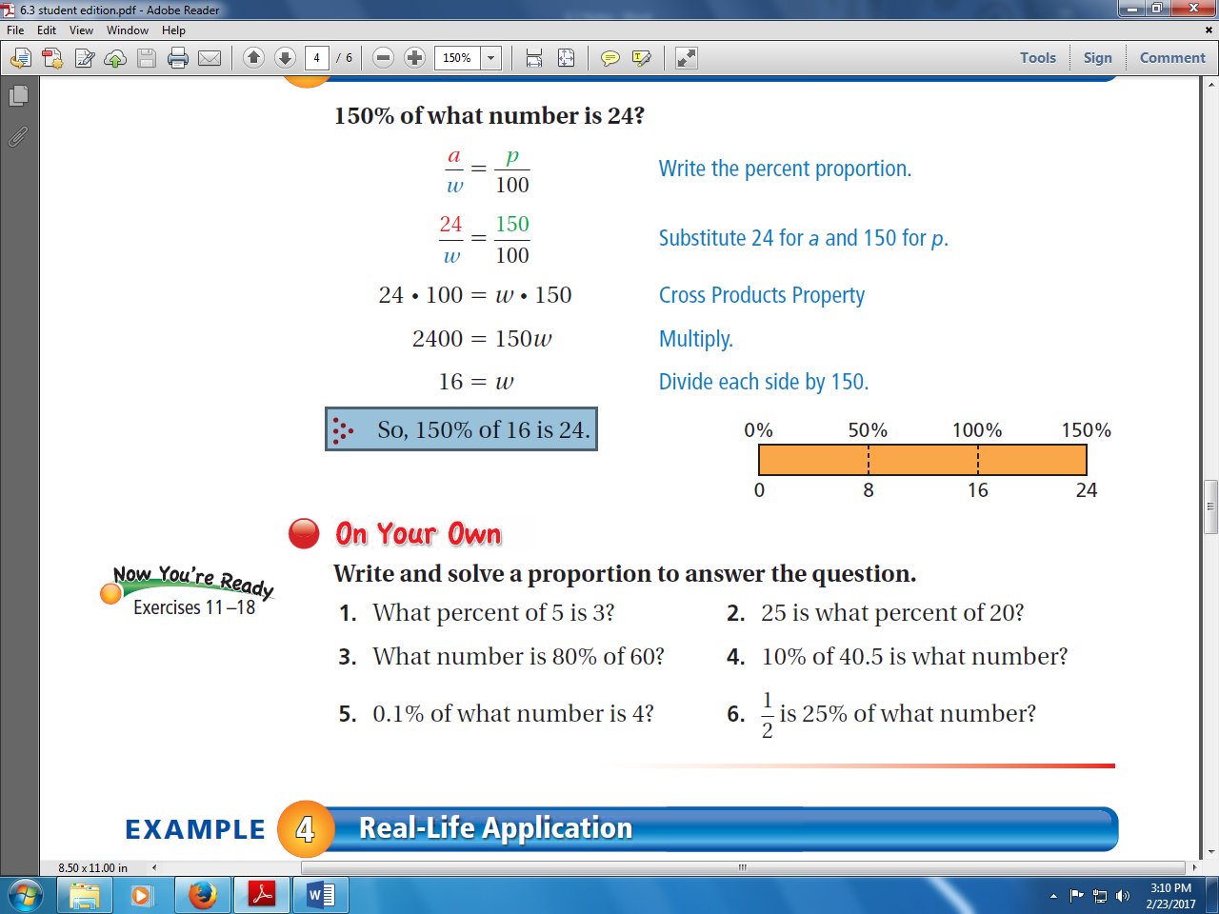

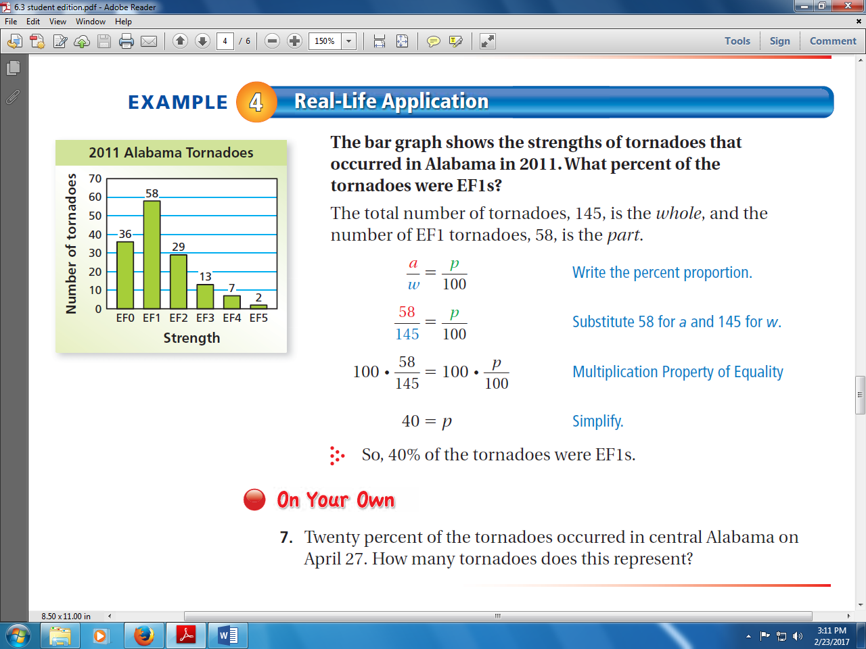

**6.3 The Percent Proportion**

EQ: _________________________________________________

____________________________________________________

Percent statements such as “25% **of** 12 is 3” give ***_______________***

values. In real-life problems, ___________ _____________ of these

numbers can be unknown. We can use the **___________________**

**______________________** to solve for ________ of the three unknowns.



= **a**

= **p**

= **w**



*In PERCENT problems, the word **OF** is usually followed by the **whole**\*



**What percent of 15 is 12?**

**Step 1: Write the percent proportion.**

**Step 2: Substitute given values for a and w.**

**Step 3: Solve for p.**

**What number is 36% of 50?**

**Step 1: Write the percent proportion.**

**Step 2: Substitute given values for w and p.**

**Step 3: Solve for a.**



**150% of what number is 24?**

**Step 1: Write the percent proportion.**

**Step 2: Substitute given values for a and p.**

**Step 3: Cross Multiply.**

**Step 4: Solve for w**.

