**Lesson 5.6b Constant of Proportionality**

**EQ: What is the constant of proportionality and how do we find it from a graph or table?**

**Constant of Proportionality:** the ratio between two directly proportional quantities.

**Slope**-The rate of change between any two points on a line.

It is a measure of the **STEEPNESS of a line**.

**REMEMBER**- a RATE is a RATIO!

**Finding SLOPE/Constant of Proportionality from a Graph:**

Find the RATIO of: **CHANGE in y** (vertical change) **over** the **CHANGE in x** (horizontal change).

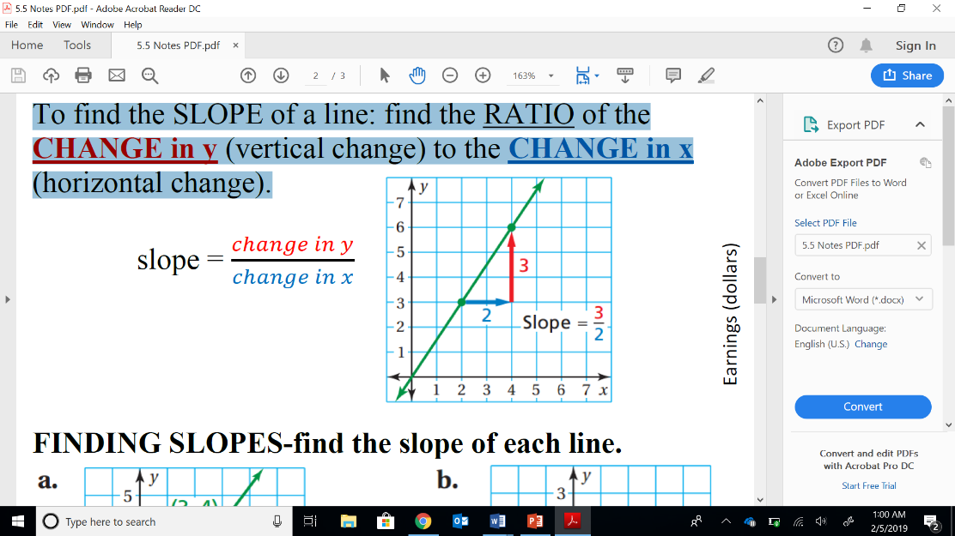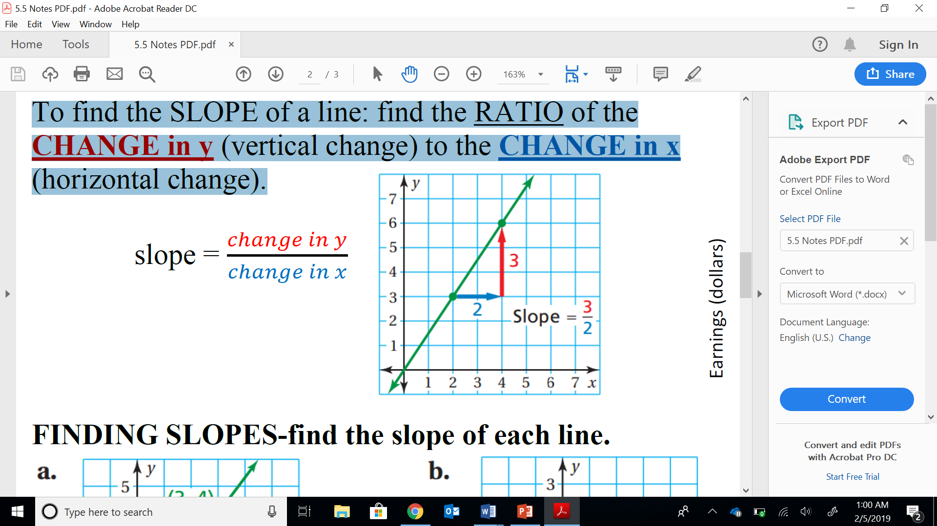EX1:

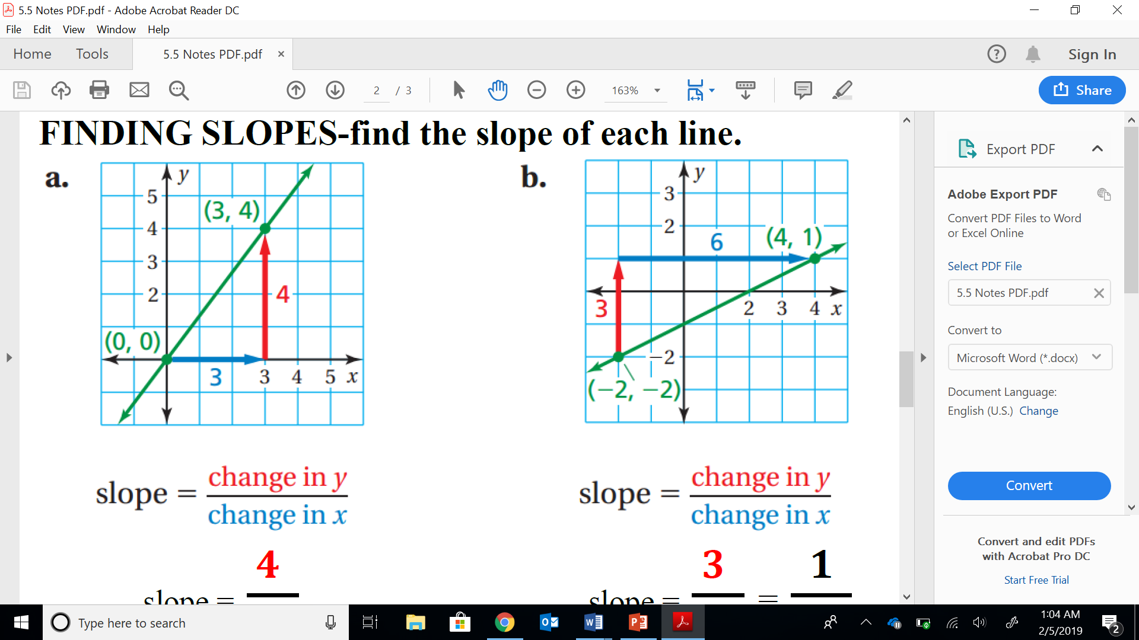

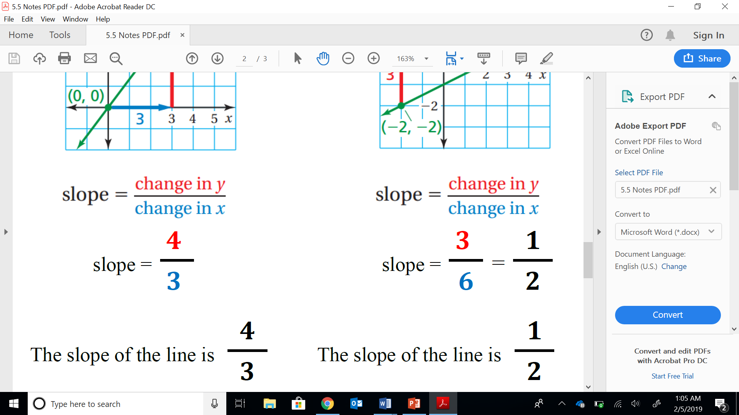

**Finding SLOPE/Constant of Proportionality from a Table:**

-The **SLOPE** of the line represents the **UNIT RATE, therefore** the **UNIT RATE** is the **SAME** as the **CONSTANT of PROPORTIONALITY.**

So, you will use ONE ratio from the table to find the **unit rate.**

**Ex1: Find the CONSTANT of PROPORTIONALITY**



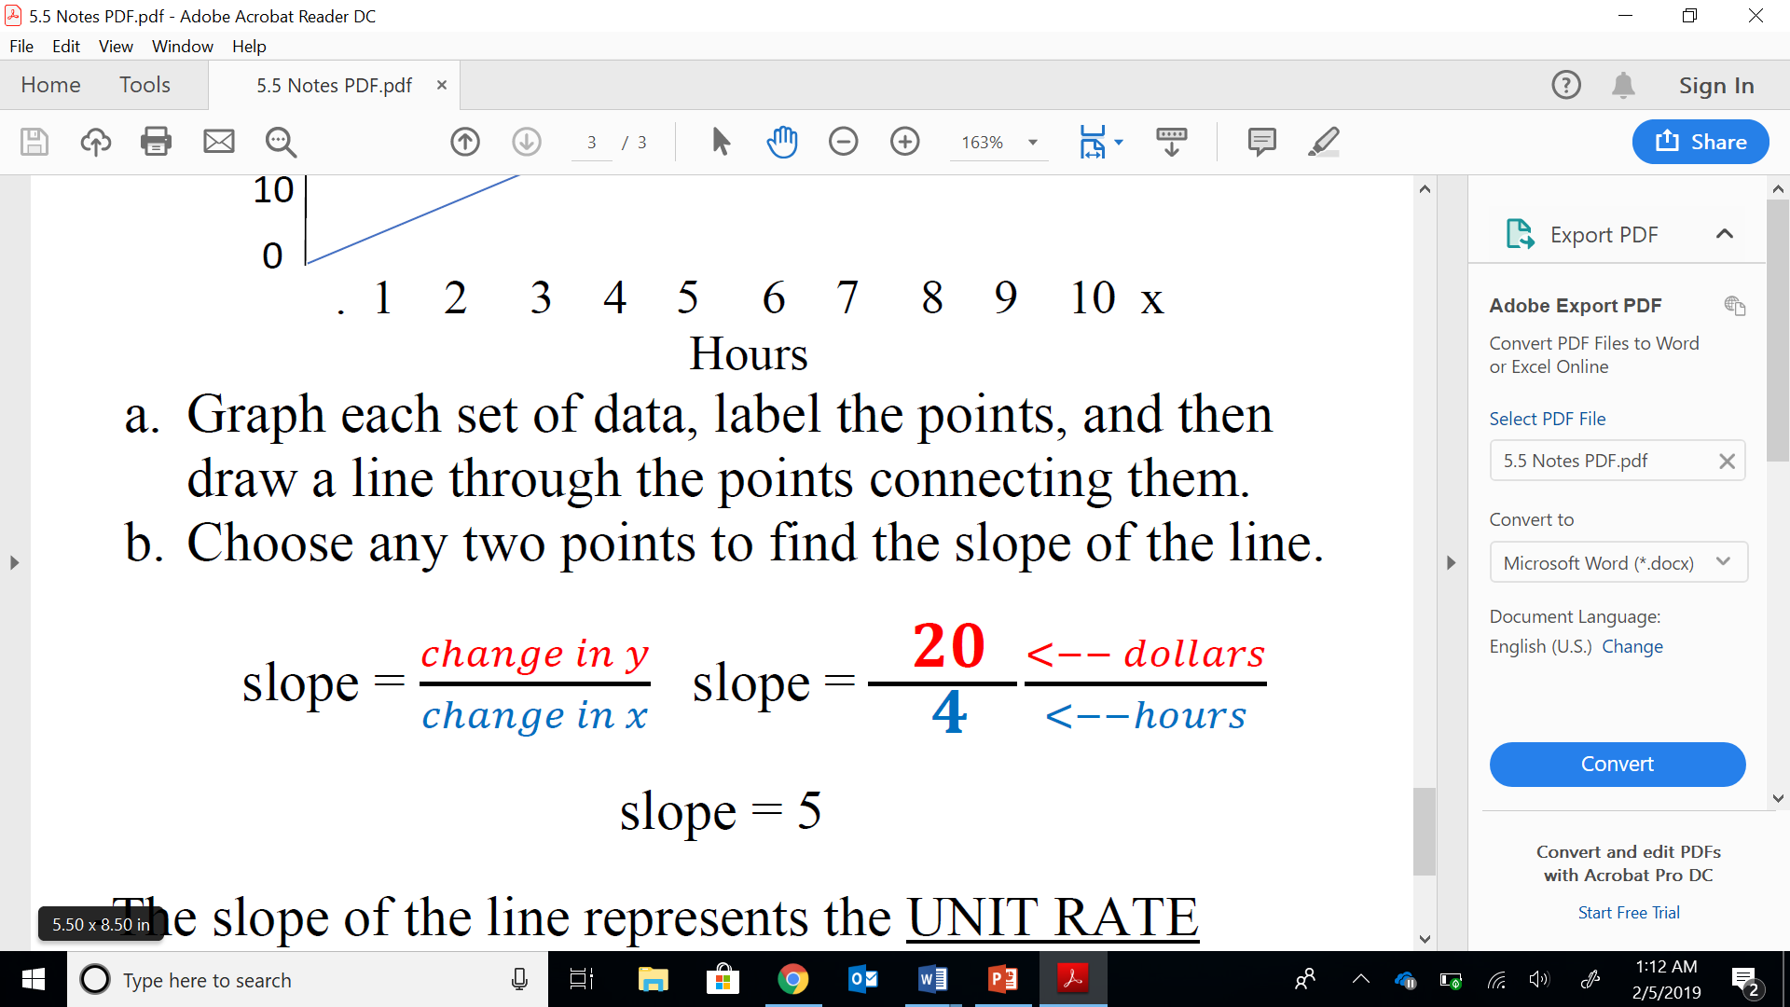

**The Constant of Proportionality is $5 per hour.**

**Ex2:** The ratio table shows the costs for different amounts of turf.

Find the unit rate in **dollars per square foot.**

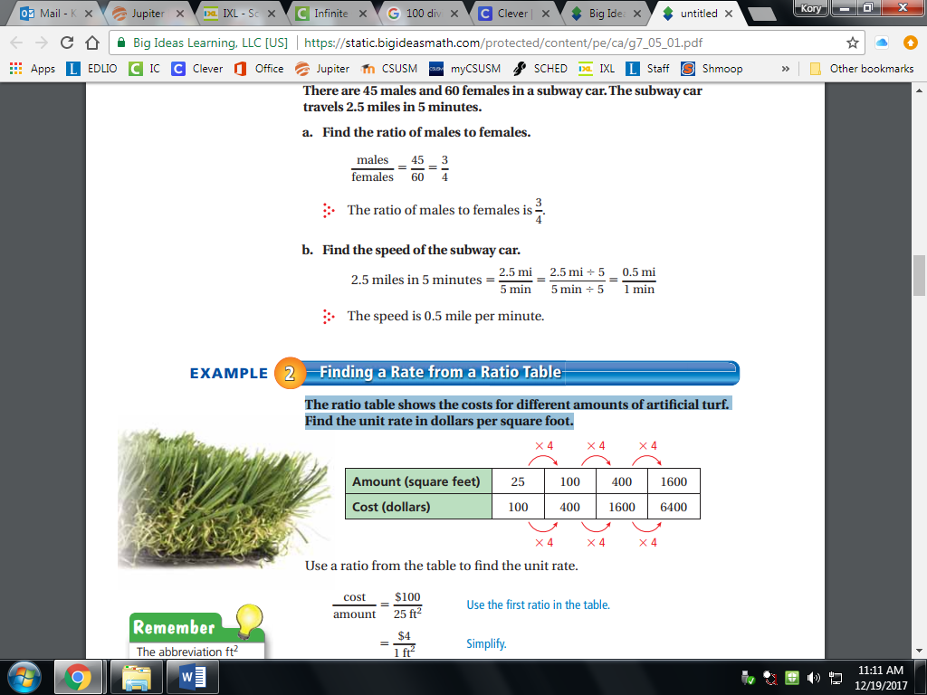

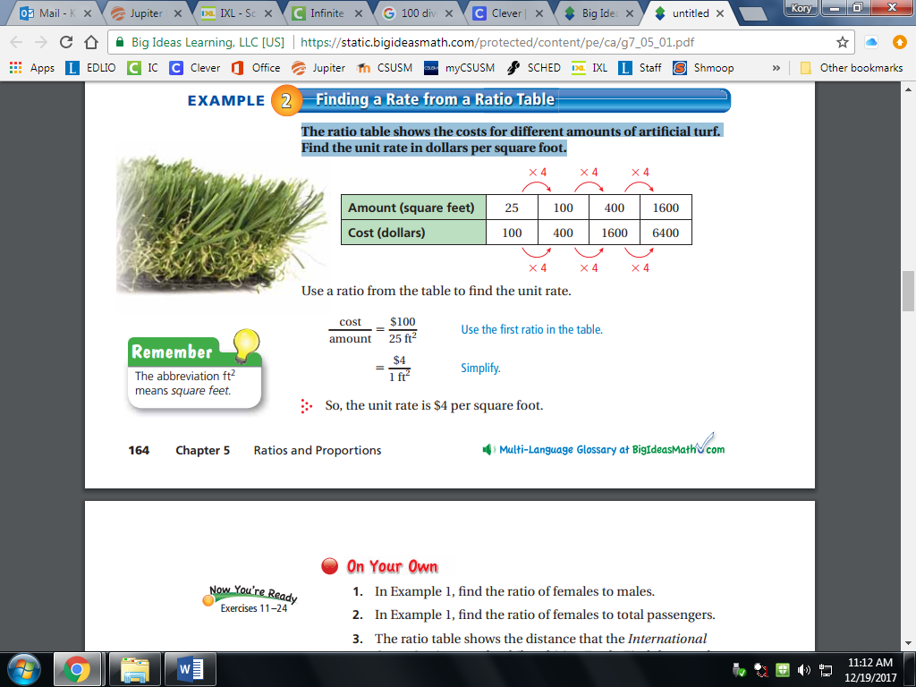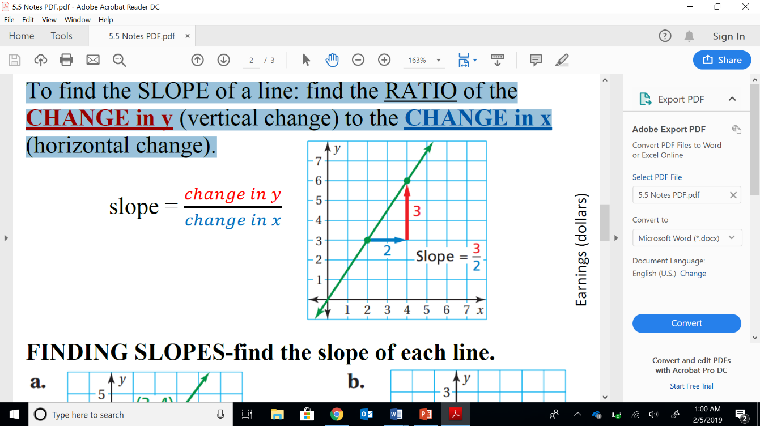 **=**

$\frac{100}{25}$ ÷ $\frac{25}{25}$ = $\frac{\$ 4}{1 sq. ft}$

The **UNIT RATE** is $4 per square foot.

|  |  |
| --- | --- |
| Practice IXL K.1 & K.4 (7th) | |
|  |  |
|  |  |
|  |  |

**Lesson 5.6b Constant of Proportionality**

**EQ: ______________________________________________**

**__________________________________________________**

**__________________________________________________**

**Constant of Proportionality:** _________________________

**__________________________________________________**

**Slope-_____________________________________________**

**__________________________________________________**

**It is a measure of the **STEEPNESS of a line**.**

**REMEMBER**- a RATE is a RATIO!

**Finding SLOPE/Constant of Proportionality from a Graph:**

Find the RATIO of: **______________** (vertical change) **over** the **_______________** (horizontal change).

EX1:



The slope of this line is: The slope of this line is:

**Finding SLOPE/Constant of Proportionality from a Table:**

-The **___________**of the line represents the **_____________,**

**therefore** the **______________________** is the **SAME** as the

**________________________________________________.**

So, you will use _____ ratio from the table to find the **unit rate.**

**Ex1: Find the CONSTANT of PROPORTIONALITY**



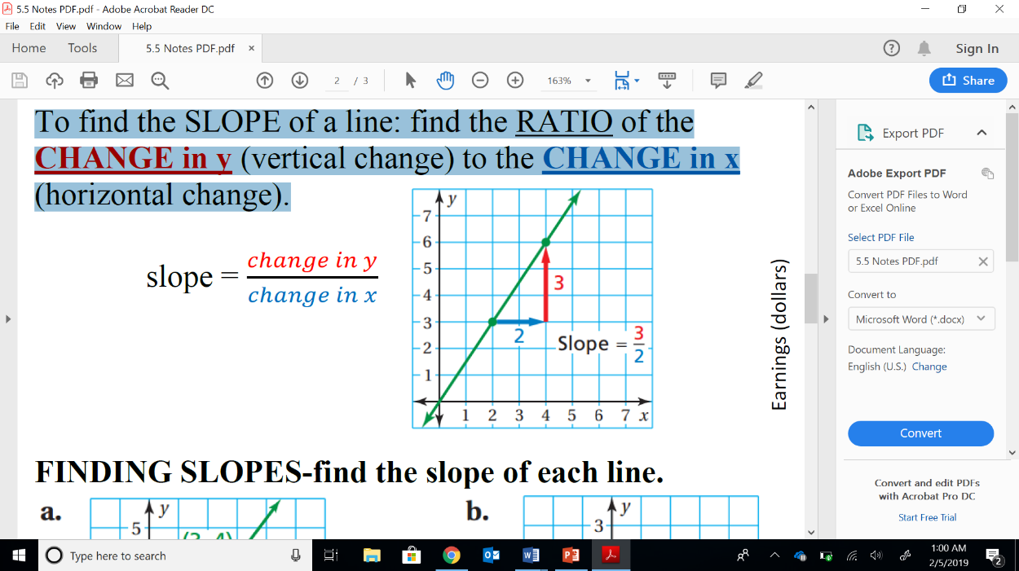 **slope = $\frac{dollars}{hour}$ =**

**Slope =**

**The Constant of Proportionality is ____________ per hour.**

**Ex2:** The ratio table shows the costs for different amounts of turf.

Find the unit rate in **dollars per square foot.**



 **=**

**The Constant of Proportionality is ____________ per ft2.**

|  |  |
| --- | --- |
| Practice IXL K.1 & K.4 (7th) | |
|  |  |
|  |  |
|  |  |