**5.4 Solving Proportions**

EQ: How can we solve proportions using a variety of strategies?

**\*\*When solving proportions, we can use the numbers that we DO KNOW, to find the number we DON’T know.\*\***

**SOLVING PROPORTIONS using Mental Math/Finding Factors**

**EX1:** Sarah bought 3 bags of chips for $2. How many bags of chips can she buy for $8?

**Step 1-** Write the proportion  **=**

**Step 2-** Using the two numbers you **KNOW** in either the numerators or denominators, determine the factor you need to multiply/divide one by to get the other.

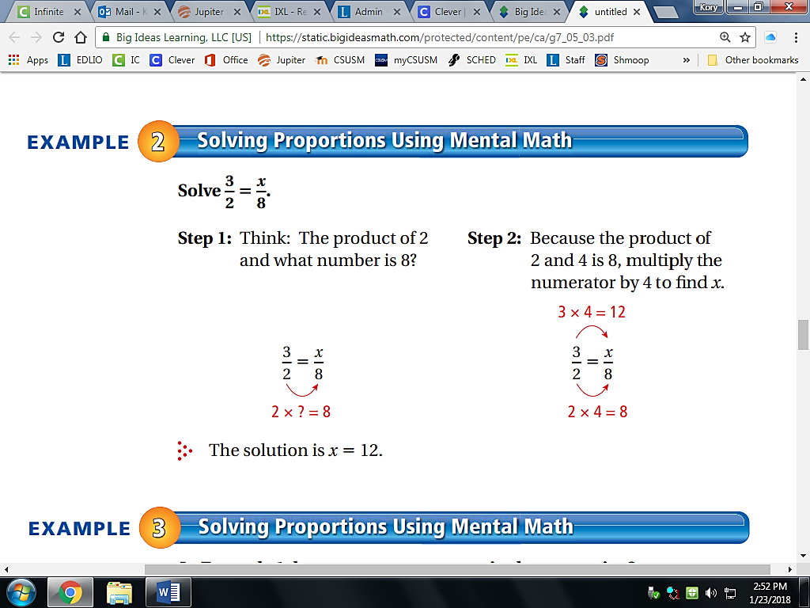 **Think about it…** What number” do I need to

MULTIPLY **_2_** by to get **_8_**?

2 x **_4_** = 8

**Step 3-** Remember, whatever you do to the TOP, you must do to the BOTTOM…or whatever you do to the BOTTOM, you must do to the top. USE the factor found in STEP 2, and perform the same operation with that factor to find your unknown value.



SO, if you **multiplied** **2** by _**4**_ on the bottom,

You must multiply **3** by _**4**_ on the top.

3 X __**4**__ = _12_

Therefore, Sarah can buy _**12**_ bags of chips for $8.

**EX2**: YESTERDAY, we wrote a proportion to find out how many tomatoes the chef needed for his new recipe. Today, we will SOLVE that proportion.

**STEP1: Write the proportion. $\frac{ 1.5 }{1}$ = $\frac{ 6 }{x}$**

**STEP 2: Think about it… STEP 3: Remember…**

“What number” do I need to SO, if I **multiplied** **1.5** by _**4**_ on top,

MULTIPLY **1.5** by to get **6**? I must multiply **1** by _**4**_ on the bottom.

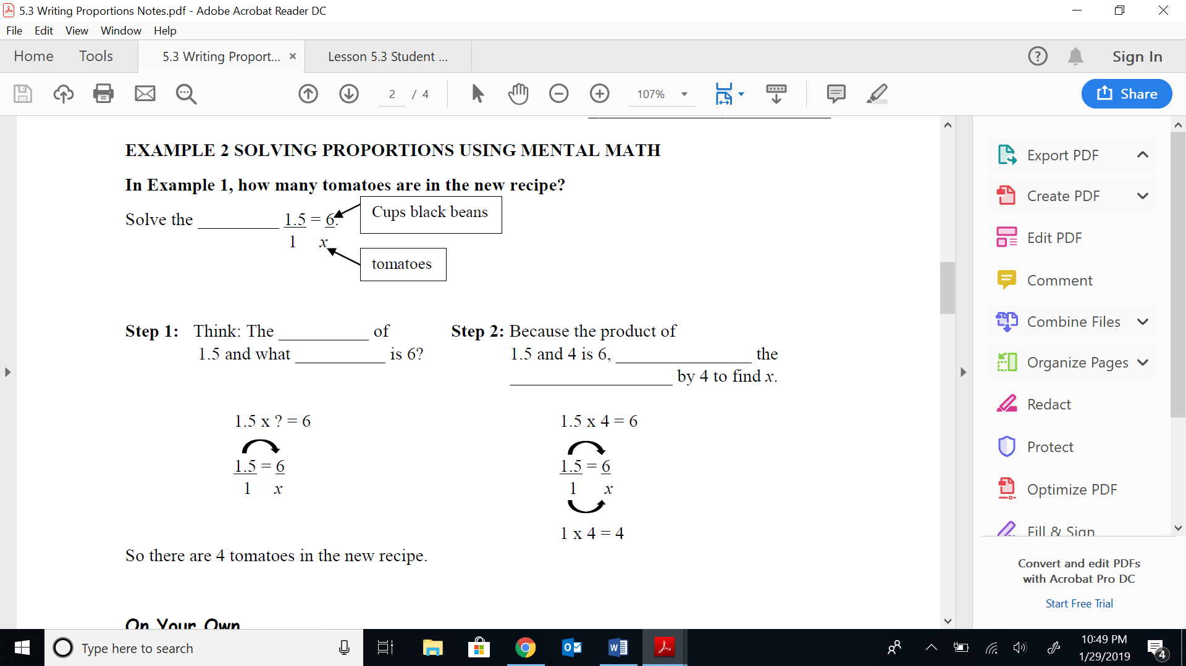 1.5 x _**4**_ = 6_



1.5 x _**4**_ = 6

1 x _**4**_ = _**4**_

Therefore, there are _4_ tomatoes in the new recipe.

**SOLVING PROPORTIONS using CROSS PRODUCTS**

**EX1:** Andy jogged 7 blocks in 10 minutes. How many blocks did he jog in 8 minutes?

**Step 1-** **Write the proportion $\frac{ 7 }{10}$**  **= $\frac{ x }{8}$**

**Step 2-** **Identify and write the cross products. = 🡪 7 * 8 = 10 * x**

**Step 3- MULTIPLY 56=10x**

**Step 4- SOLVE the EQUATION 56 = 10x 🡪**

Divide both sides by the 10 10 🡪 **5.6 = x**

number next to the variable.

**Therefore, Andy jogged _5.6_ blocks in 8 minutes.**

**EX1:** Mrs. Stare helped 3 students in 17 minutes. At that pace, how many minutes would it take her to help 9 students?

**Step 1-** **Write the proportion $\frac{ 3 }{17}$**  **= $\frac{ 9 }{m}$**

**Step 2-** **Identify and write the cross products. = 🡪 3*m = 9 * 17**

**Step 3- MULTIPLY 3m=153**

**Step 4- SOLVE the EQUATION 3m = 153 🡪**

Divide both sides by the 3 3 🡪 **51 = m**

number next to the variable.

**Therefore, it would take Mrs. Stare 51 minutes to help 9 students.**

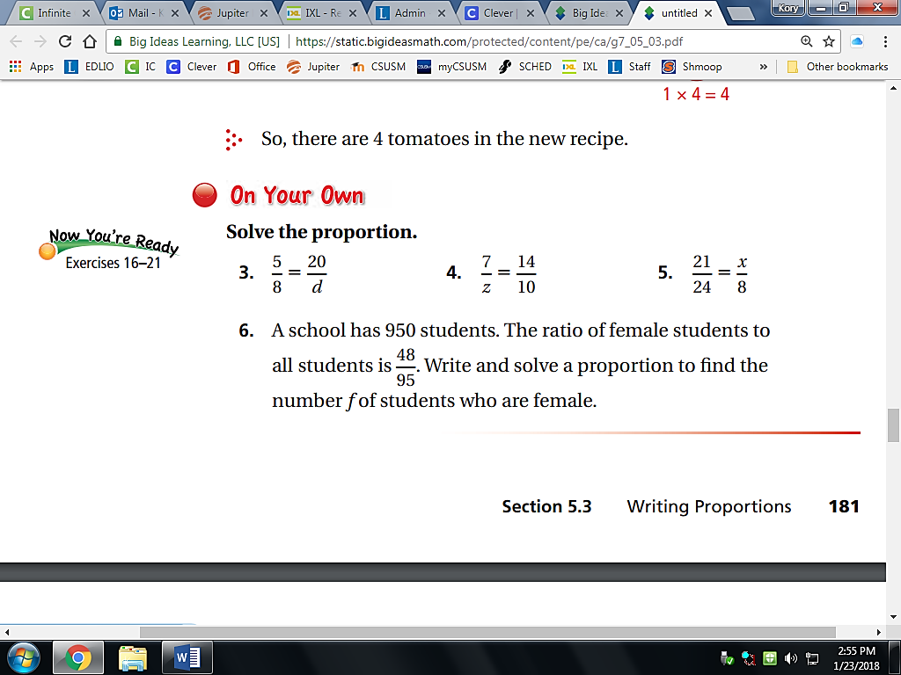

**5.4 Solving Proportions**

EQ: _________________________________________________

____________________________________________________

**\*\*When solving proportions, we can use the numbers that we DO KNOW, to find the number we DON’T know.\*\***

**SOLVING PROPORTIONS using Mental Math/Finding Factors**

**EX1:** Sarah bought 3 bags of chips for $2. How many bags

of chips can she buy for $8?

**Step 1-** Write the proportion  **=**

**Step 2-** Using the two numbers you **KNOW** in either the numerators or denominators, determine the factor you need to multiply/divide one by to get the other.

**Think about it:** What number do I need to

MULTIPLY **___** by to get **___**? 2 x **____** = 8

**Step 3-** Remember, whatever you do to the TOP, you must do to the BOTTOM, and whatever you do to the BOTTOM, you must do to the top. USE the factor found in STEP 2, and perform the same operation with that factor to find your unknown value.

SO, if you **multiplied** **2** by _**___**_ on the bottom,

You must multiply **3** by _____ on the top.

3 X ______ = ______

Therefore, Sarah can buy _**____**_ bags of chips for $8.

**EX2**: YESTERDAY, we wrote a proportion to find out how many tomatoes the chef needed for his new recipe. Today, we will SOLVE that proportion.

**STEP1: Write the proportion. =**

**STEP 2: Think about it… STEP 3: Remember…**

“What number” do I need to SO, if I **multiplied** **1.5** by **___**_on top,

MULTIPLY **1.5** by to get **6**? I must multiply **1** by **___** on the bottom.

 1.5 x **___**_= 6_



1.5 x **___**_= 6

1 x **___**_=  **___**_

Therefore, there are **___**_tomatoes in the new recipe.

**SOLVING PROPORTIONS using CROSS PRODUCTS**

**EX1:** Andy jogged 7 blocks in 10 minutes. How many blocks did he jog in 8 minutes?

**Step 1-** **Write the proportion**  **=**

**Step 2-** **Identify and write the cross products.**

**Step 3- MULTIPLY**

**Step 4- SOLVE the EQUATION**

Divide both sides by the

number next to the variable.

**Therefore, Andy jogged _______ blocks in 8 minutes.**

**EX1:** Mrs. Stare helped 3 students in 17 minutes. At that pace, how many minutes would it take her to help 9 students?

**Step 1-** **Write the proportion**  **=**

**Step 2-** **Identify and write the cross products.**

**Step 3- MULTIPLY**

**Step 4- SOLVE the EQUATION**

Divide both sides by the

number next to the variable.

**Therefore, it would take Mrs. Stare____minutes to help 9 students.**



**5.4 Solving Proportions**

EQ: _________________________________________________

____________________________________________________

**\*\*When solving proportions, we can use the numbers that we DO KNOW, to find the number we DON’T know.\*\***

**SOLVING PROPORTIONS using Mental Math/Finding Factors**

**EX1:** Sarah bought 3 bags of chips for $2. How many bags

of chips can she buy for $8?

**Step 1-** Write the proportion  **=**

**Step 2-** Using the two numbers you **KNOW** in either the numerators or denominators, determine the factor you need to multiply/divide one by to get the other.

**Think about it:** What number do I need to

MULTIPLY **___** by to get **___**? 2 x **____** = 8

**Step 3-** Remember, whatever you do to the TOP, you must do to the BOTTOM, and whatever you do to the BOTTOM, you must do to the top. USE the factor found in STEP 2, and perform the same operation with that factor to find your unknown value.

SO, if you **multiplied** **2** by _**___**_ on the bottom,

You must multiply **3** by _____ on the top.

3 X ______ = ______

Therefore, Sarah can buy _**____**_ bags of chips for $8.

**EX2**: YESTERDAY, we wrote a proportion to find out how many tomatoes the chef needed for his new recipe. Today, we will SOLVE that proportion.

**STEP1: Write the proportion. =**

**STEP 2: Think about it… STEP 3: Remember…**

“What number” do I need to SO, if I **multiplied** **1.5** by **___**_on top,

MULTIPLY **1.5** by to get **6**? I must multiply **1** by **___** on the bottom.

 1.5 x **___**_= 6_



1.5 x **___**_= 6

1 x **___**_=  **___**_

Therefore, there are **___**_tomatoes in the new recipe.

**SOLVING PROPORTIONS using CROSS PRODUCTS**

**EX1:** Andy jogged 7 blocks in 10 minutes. How many blocks did he jog in 8 minutes?

**Step 1-** **Write the proportion**  **=**

**Step 2-** **Identify and write the cross products.**

**Step 3- MULTIPLY**

**Step 4- SOLVE the EQUATION**

Divide both sides by the

number next to the variable.

**Therefore, Andy jogged _______ blocks in 8 minutes.**

**EX1:** Mrs. Stare helped 3 students in 17 minutes. At that pace, how many minutes would it take her to help 9 students?

**Step 1-** **Write the proportion**  **=**

**Step 2-** **Identify and write the cross products.**

**Step 3- MULTIPLY**

**Step 4- SOLVE the EQUATION**

Divide both sides by the

number next to the variable.

**Therefore, it would take Mrs. Stare____minutes to help 9 students.**

