Decimal

to

FRACTION

**. 5 🡪**

PERCENT

to

DECIMAL

**50% 🡪 . 5**

FRACTION

to

DECIMAL

**🡪. 5**

Decimal

to

PERCENT

**. 5 🡪50%**

PERCENT

to

FRACTION

**50% 🡪**

FRACTION

to

PERCENT

**🡪 50%**

**Decimal to Percent D 🡪 P**

**Step 1-** Move the decimal to the **RIGHT** **two places**

(the same as multiplying by 100).

**Ex:** .47 = 47.

**Step 2-** Add the percent symbol.

**Ex:** 47. = 47**%**

**Percent to Fraction**

**Step 1-** Write the percent as the **numerator** & **100** as the **denominator.**

**EX: 45% = $\frac{45}{100}$**

**Step 2**- Reduce/Simplify. **EX: $\frac{45}{100}$**  **÷ $\frac{5}{5}$ = $\frac{9}{20}$**  So, **45%** =

***If the fraction has a decimal in the numerator, follow step 1, then:

**Step 2**- move the decimal to the right to get it out of the numerator.

**EX:** 1.25% = =

**Step 3**- add as many zeros to the end of the **100** in the denominator as the number of spaces as you moved the decimal in the numerator.

**EX: $\frac{125 }{10000 (added two zeros to 100)}$**

**Step 4**- Reduce/Simplify **EX. $\frac{125}{10000}$** ÷ $\frac{25}{25}$ = $\frac{5}{400}$ ÷ $\frac{5}{5}$ = $\frac{1}{80}$ So, **1.25%** = $\frac{1}{80}$

**Fraction to Percent**

**Step 1**- Multiply the fraction by $\frac{100}{1}$.

**Ex: $\frac{1}{4}$**  x $\frac{100}{1}$ = $\frac{100}{4}$

**Step 2**- Reduce/Simplify. **Ex: $\frac{100}{4}$** ÷ $\frac{4}{4}$ = $\frac{25}{1}$ = 25

**Step 3**- Add the percent sign. **Ex:** 25 = **25%**

**Decimal to Fraction**

**Step 1**-Write the **number to the left** of the decimal as the

**WHOLE NUMBER**. **EX:** **5**.25 🡪 **5**

**Step 2**-Write the **numbers to the right** of the decimal as the **NUMERATOR** of the fraction. **EX:** 5.25 🡪 5 $\frac{25}{ }$

**Step 3**- Write a **1 AND one zero for each of the digits to the right of the decimal** as the DENOMINATOR of the fraction.

**EX:** 5.25 🡪 5 $\frac{25}{100 }$

**Step 4**- Reduce/Simplify **EX:** 5 $\frac{25}{100 }$ ÷ $\frac{25}{25}$ = **5 $\frac{1}{4 }$**

**Percent to Decimal D 🡨 P**

**Step 1**- Remove the percent symbol **Ex.** 23% = 23

**Step 2**- Move the decimal to the **LEFT** **two places** (the same as dividing by 100).

Ex: 23% = 23 = .23

**Fraction to Decimal**

**Step 1**- Divide the top number by the bottom.

**Step 2**- Stop when the remainder is 0, or if needed,

continue to four places past the decimal to see if

the decimal repeats. **EX:** .4545 repeats so, $\frac{5}{11}$ **=**

\*\***IF the fraction is a mixed number**, put the whole number in front of the decimal and divide the top number of the fraction by the bottom number like above. EX. 6 🡪 6.4

**Decimal to Percent D 🡪 P**

**Step 1-** Move the decimal to the **RIGHT** **two places**

(the same as multiplying by 100).

**Ex:** .47 =

**Step 2-** Add the percent symbol.

**Ex:**

**Percent to Fraction**

**Step 1-** Write the percent as the **numerator** & **100** as the **denominator.**

**EX: 45% =**

**Step 2**- Reduce/Simplify. **EX: $\frac{45}{100}$**  So, **45%** =

***If the fraction has a decimal in the numerator, follow step 1, then:

**Step 2**- move the decimal to the right to get it out of the numerator.

**EX:** 1.25% = =

**Step 3**- add as many zeros to the end of the **100** in the denominator as the number of spaces as you moved the decimal in the numerator.

**EX: $\frac{ }{ (added two zeros to 100)}$**

**Step 4**- Reduce/Simplify **EX.** So, **1.25%** =

**Fraction to Percent**

**Step 1**- Multiply the fraction by $\frac{100}{1}$.

**Ex: $\frac{1}{4}$**  x =

**Step 2**- Reduce/Simplify. **Ex:**

**Step 3**- Add the percent sign. **Ex:**

**Decimal to Fraction**

**Step 1**-Write the **number to the left** of the decimal as the

**WHOLE NUMBER**. **EX:** **5**.25 🡪

**Step 2**-Write the **numbers to the right** of the decimal as the

**NUMERATOR** of the fraction. **EX:** 5.25 🡪 5

**Step 3**- Write a **1 AND one zero for each of the digits to the right of the decimal** as the DENOMINATOR of the fraction.

**EX:** 5.25 🡪 5 $\frac{25}{ }$

**Step 4**- Reduce/Simplify **EX:** 5 $\frac{25}{100 }$

**Percent to Decimal D 🡨 P**

**Step 1**- Remove the percent symbol **Ex.** 23% =

**Step 2**- Move the decimal to the **LEFT** **two places** (the same as dividing by 100).

Ex:

**Fraction to Decimal**

**Step 1**- Divide the top number by the bottom. Ex: $\frac{5}{11}$

**Step 2**- Stop when the remainder is 0, or if needed,

continue to four places past the decimal to see if

the decimal repeats. **EX:**

\*\***IF the fraction is a mixed number**, put the whole number in front of the decimal and divide the top number of the fraction by the bottom number like above. EX. 6 🡪

**6.1 ON YOUR OWN PRACTICE**

**Write the Fraction as a Decimal**

1. $\frac{6}{5}$ 2) 7 $\frac{3}{8}$ 3) $\frac{3}{11}$

**Write the Decimal as a Fraction**

1. .07 2) 3.125 3) 10.25

**Write the Percent as a Fraction**

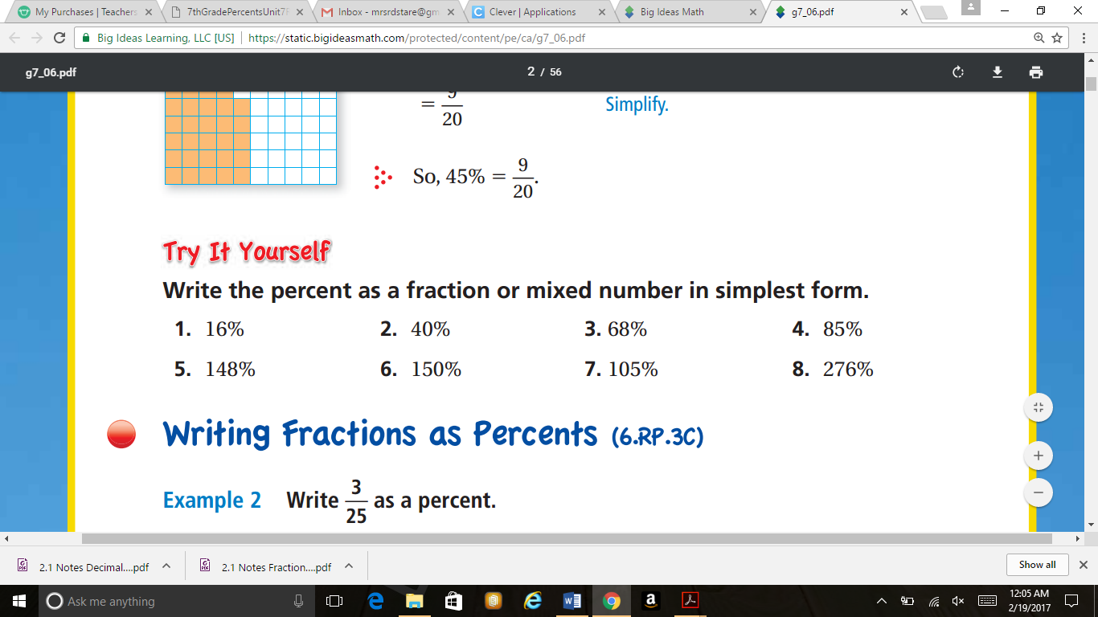



**Write the Fraction as a Percent**

1. 2) 1 3)

4) 2 5) 6)

**Write the Percent as a Decimal- D 🡨 P**

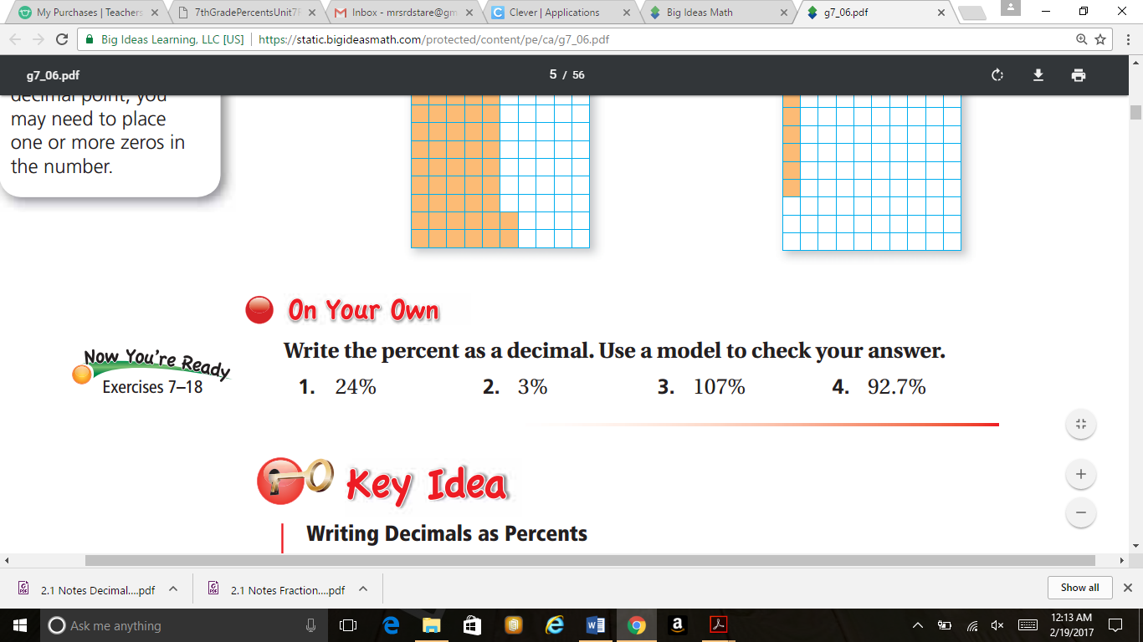

**Write the Decimal as a Percent – D 🡪 P**

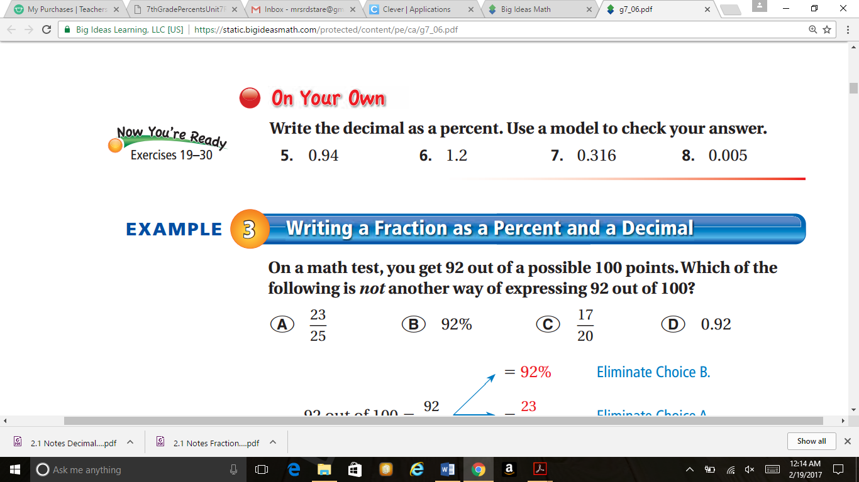

**6.1 ON YOUR OWN PRACTICE**

**Write the Fraction as a Decimal**

1. $\frac{6}{5}$ 2) 7 $\frac{3}{8}$ 3) $\frac{3}{11}$

**Write the Decimal as a Fraction**

1. .07 2) 3.125 3) 10.25

**Write the Percent as a Fraction**





**Write the Fraction as a Percent**

1. 2) 1 3)

4) 2 5) 6)

**Write the Percent as a Decimal- D 🡨 P**



**Write the Decimal as a Percent – D 🡪 P**

